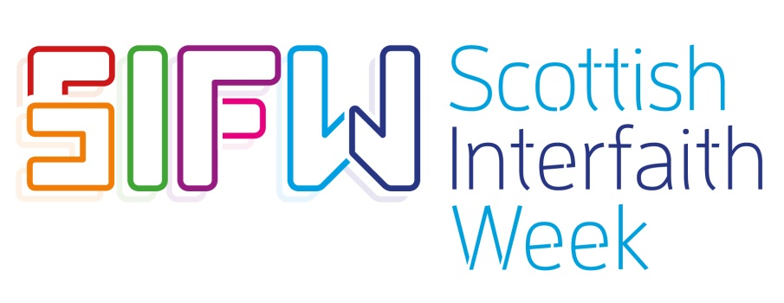

Here are some ideas for simple activities that could be held to explore our theme ‘Eat, Share, Love’
‘Doors open for SIFW’: Open your places of worship and homes and share a cup of tea and some food with your community
‘Faith and food’: exactly what it says on the tin! Share food and understanding of your faith with others
Organise a visit to your local Gurdwara and experience their Langar. Langar is the term used in Sikhism for the community kitchen in a Gurdwara where a free vegetarian meal is served to all the visitors
Hold a Mindful eating and meditation evening
Dine and Dialogue: Enjoy different cuisines and interfaith based discussions
Host a traditional Jewish Friday night dinner
Show and Tell: host an event where attendees bring along a dish or drink attached to a memory from their respective faiths or religious festivals for discussion and sharing
Cooking Competition: invite people from different backgrounds to sign up and find a panel of judges for a fun and competitive evening
Interfaith Movie Night: project your favourite film connected to faith, followed by tea, cake and a chat
Dedicate your book club in November to an interfaith based book of your choice
Host an event to connect people from different generations and backgrounds for dialogue on tackling loneliness and isolation, with a focus on the healing power of good food and company
Climate Change: host an event to highlight how essential it is for people from all backgrounds coming together to sustain the planet, with a focus on sustainable eating habits
Why not invite a speaker along to your event, to enlighten a diverse group on the historical connection between food and faith, facilitate a discussion on the halal/kosher meat debate, discuss veganism etc
‘Food and festivals’: host people from different communities to share food eaten at your religious festivals, followed by dialogue on the festival’s meaning / significance
‘Ladies who lunch’: gather women from different communities to engage over food and dialogue
Family fun day: host a family fun day with different cultural activities for every generation to enjoy
Cooking workshops: learn how to make food from different cultures and discuss the meaning behind them
Bond over baking: get together to showcase your baking skills (e.g. a Jewish Challah bake or Indian deserts) then chat over some cultural sweet treats!
Potluck Party: Bring a dish and share what it means to you
Tea with me: Put on the kettle, get out the biscuits and share stories of your culture and faith
Volunteer at a soup kitchen or homeless charity: gather people from different communities for a morning of volunteering, followed by dialogue on access to good food and the impact it can have
Quiz nights: can be done easily from most venues. Why not have themed categories for food and faith?
Open mic: use the arts as a way to engage and bring together people from different backgrounds
Interfaith Ceilidh – a good old fashioned traditional Scottish way of bringing people together through dance, music and food
Self - Care Sunday: share health & well-being tips and good food for the body and soul
Visit existing community projects as a group and help enhance important ongoing work in your community i.e. organic and sustainable food growth, climate / environment projects, women’s events etc
Day of Rest: Nurture your body and soul through meditation, mindfulness, spirituality and healthy refreshments for a well-needed recharge

