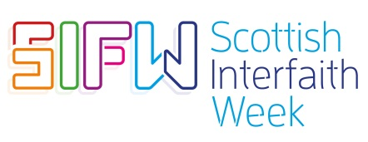

‘Eat Share Love’ Competition Entry Form 2019

Please complete all parts of this form.

- To be completed by the individual or group

Name:

Age:

Email address:

Phone number:

Name of School/Group/Place of Worship (if appropriate):

Please give a short description of how your piece of work meets the theme of ‘Eat Share Love’

I can confirm that this work being submitted is an original piece of my / our own work and does not belong to any other person.

Signature:_________________________________________________________

Date: _____________________________________________________________

Mark your envelope ‘Scottish Interfaith Week Competition’ and send to

Interfaith Scotland
Flemington House
110 Flemington Street
Glasgow G21 4BF

Alternatively you can take a photo or make a digital file of your music or video and email it to frances@interfaithscotland.org

The closing date is Tuesday 29th October 2019

