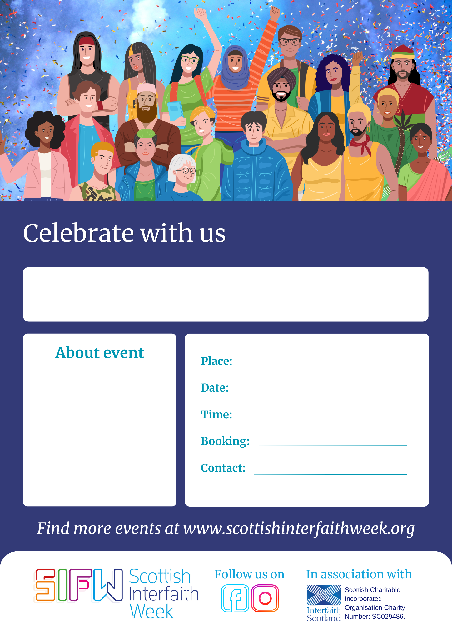
[Click here to edit header]
[Click here to add a blurb about your event]
[Add venue address here]
[Add date of event here]
[Add details about if and how attendees should register for the event]
[Add event organiser contact details, including email address]
[Add time of event here]

